Exhibiting Sponsorship Package

Conference Overview
- This year will feature a conference and a traditional tradeshow experience with separate but connected exhibitor area and attendee area.
- There is dedicated exhibit time on both days.
- Exhibits will be accessible to attendees all day both days, not just during dedicated exhibit time.
- Exhibit space is designed to have easy access to the attendee area. The exhibit and attendee spaces are divided by an airwall with doors leading in and out of both areas.
  - In addition to the price of sponsorship, a refundable deposit of $250 will be required of each sponsor, to be returned if exhibits are broken down after the conference is over at 4:15 p.m. on February 18, 2022.
  - If Exhibiting Sponsors want to participate only on the first day, the price remains the same, but they may break down their exhibits after the reception on February 17. Any unoccupied space will be re-sold and/or otherwise utilized throughout the rest of the conference.
- Vendors who want to attend instead of sponsoring will be subject to surcharge pricing ($1,000) in order to protect our Exhibiting Sponsors’ benefits. This rate exceeds the lowest sponsorship rate. We highly suggest that vendors sponsor rather than attend. Non-sponsor vendors WILL NOT be allowed to distribute marketing materials in the showroom or use the meeting space designated for sponsors to meet with clients.
- Please make purchases online at www.AZSelfStorage.org.

Agenda (subject to change as agenda is developed)

Golf – Wednesday, February 16, 2022 - TBD
8 am-7 pm Exhibit set up

Owners Summit – Thursday, February 17. 2022
6-8:30 am Exhibit set up
9 am-4:30 pm Presentations and dedicated exhibit time during the day; exhibits available to attendees throughout the day
5:30 -7:30 pm AZSA’s 25th Anniversary Party
Please help us celebrate. More details coming shortly.

Operational Symposium – Friday, February 18, 2022
8 am-4:15 pm Presentations and dedicated exhibit time during the day; exhibits available to attendees throughout the day
4:15-6 pm Exhibit breakdown

Floor Plan

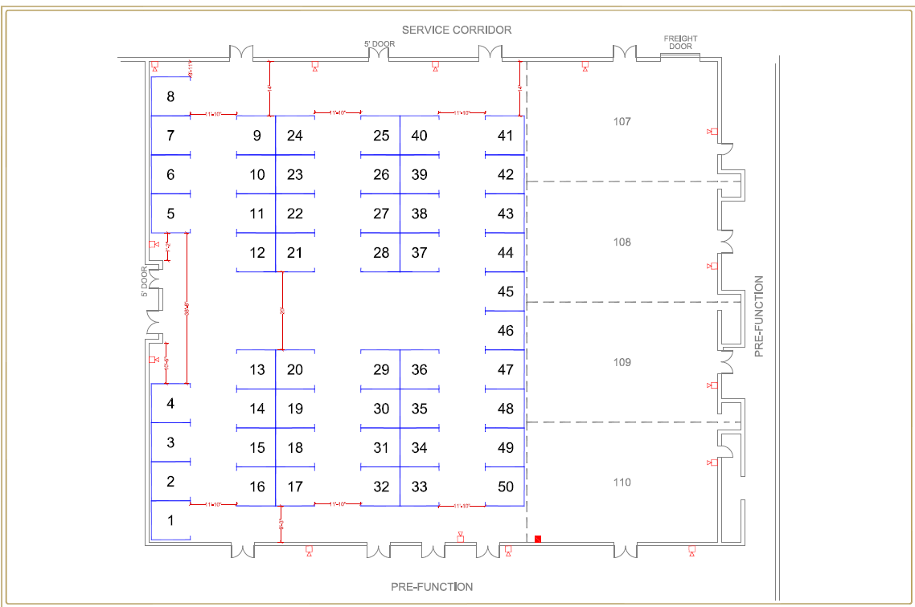

Exhibiting Sponsorships

Last year’s Title, Promo, and Major Sponsors have a right of first refusal until November 9, 2021, to continue their sponsorships.

- Title Sponsor: $5,000
- Promotional / Major Sponsor: $3,500
- Exhibitors: $750

Spaces and Prices

Space # | Sponsor Type | Cost | Space # | Sponsor Type | Cost
1 | Title Sponsor | $5,000 | 26 | Exhibitor | $750
2 | Promotional Sponsor-Sold Out | $5,000 | 27 | Exhibitor | $750
3 | Major Sponsor | $3,500 | 28 | Exhibitor | $750
4 | Major Sponsor | $3,500 | 29 | Exhibitor | $750
5 | Major Sponsor | $3,500 | 30 | Exhibitor | $750
6 | Major Sponsor | $3,500 | 31 | Exhibitor | $750
7 | Major Sponsor | $3,500 | 32 | Exhibitor | $750
8 | Major Sponsor | $3,500 | 33 | Exhibitor | $750
9 | Major Sponsor | $3,500 | 34 | Exhibitor | $750
10 | Exhibitor | $750 | 35 | Exhibitor | $750
11 | Exhibitor | $750 | 36 | Exhibitor | $750
12 | Exhibitor | $750 | 37 | Exhibitor | $750
13 | Exhibitor | $750 | 38 | Exhibitor | $750
14 | Exhibitor | $750 | 39 | Exhibitor | $750
15 | Exhibitor | $750 | 40 | Exhibitor | $750
16 | Exhibitor | $750 | 41 | Exhibitor | $750
17 | Exhibitor | $750 | 42 | Exhibitor | $750
18 | Exhibitor | $750 | 43 | Exhibitor | $750
19 | Exhibitor | $750 | 44 | Exhibitor | $750
20 | Exhibitor | $750 | 45 | Exhibitor | $750
21 | Exhibitor | $750 | 46 | Exhibitor | $750
22 | Exhibitor | $750 | 47 | Exhibitor | $750
23 | Exhibitor | $750 | 48 | Exhibitor | $750
24 | Exhibitor | $750 | 49 | Exhibitor | $750
25 | Exhibitor | $750 | 50 | Exhibitor | $750

Other Sponsorship Opportunities (Details Coming Soon) or contact Amy Amideo, 602.374.7184

Keynote - $6,000 (1)
Owners & Investor Summit Luncheon - $5,000 (3)
Operational Symposium Luncheon - $5,000 (3)
Owners & Investor Summit Breakfast - $2,500 (4)
Operational Symposium Breakfast - $2,500 (4)
AZSA 25th Party - $5,000 (3)
Beverage Sponsorship - $2,500 (2)
Snack Sponsorship - $2,500 (2)
Session Sponsors - $1,500 (6)
Tote bags - $1,800 (1)
Name badges - $1,500 (1)
Ceremonial Opening Tribal Blessing - $800 (2) – MiniCo Publishing – Sold Out
Sponsorship Benefits

Benefits for all Exhibiting Sponsors include:
- 2* people with access to all events on February 17 & 18, including meal and drink tickets
- Electricity upon request, at no additional cost
- Logo in sponsor video, shown throughout the 2-day conference
- Sponsor Material in Attendee Handouts – 1-page inserts supplied by sponsor in attendee tote bags
- On-stage announcement of door prize winners, after lunch on February 18
*contact AZSA for adding additional people

Title Sponsor –
  - First choice of exhibit space
  - 2-Minute Presentation by Sponsor at Opening Session both days
  - Logo on name badges
  - All Major Sponsor benefits shown below

Promotional Sponsor – MiniCo Publishing
  - First choice of exhibit space after Title Sponsor
  - All Major Sponsor benefits shown below

Major Sponsors – 7 spaces – 6 spaces left
  - Choice of best exhibit spaces after Title & Promo Sponsors
  - On-stage introductions both days of conference
  - Pre- and post-conference promotion, with logo on digital brochures, postcards, name badges, conference slide show, event posters, e-Bulletins, website ads, other promotional material
  - Recognition in AZSA’s print newsletter, Behind Closed Doors
  - Recognition in all ads in trade publications such as Mini-Storage Messenger, ISS, SSA Magazine
  - Additional drink tickets to give to attendees

Exhibitor – 41 Spaces

- All benefits listed on top of page

Charity Sponsor – Storage Gives – More details coming soon!

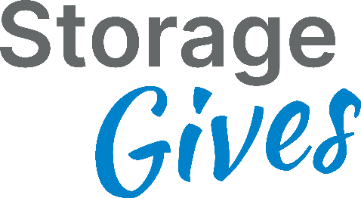

Specifications

- Space:

- Set up and break down times are strict. All exhibits must be set up by 8:30 am on Thursday, February 17; breakdown may not start until 4:15 pm on Friday, February 18. Please plan accordingly. Exhibitors breaking down early will forego the $250 deposit.
- All space includes electricity if you request it.
- Exhibiting Sponsors may not sublet, assign, or share any part of space allocated to them without the written consent of AZSA. Exhibits, signs, and displays are also prohibited in any of the public areas or elsewhere on the premises of the hotel facilities. Any company not assigned space is prohibited from hosting hospitality suites or displaying or distributing materials at the hotel.

- Exhibit Details:

  - Exhibits:
    - All exhibits are 10’x 10’ pipe & drape booths. Each booth will consist of 8’ high back wall, 3’ high side rails, one wastebasket and one 7” x 44” ID sign.
    - For other booth and event enhancements like charging stations, furniture and other products please contact Amy Amideo, for more information.

- Floor plan, traffic flow, and other issues:

- Floor plan is approximate
- Entrance/exit – as marked
- Meals:
  - Buffet – Ticketed meals will be served buffet style in the exhibit hall
  - Meal seating – will be in the attendee seating areas & other designated areas
- Beverage service - will be throughout both days; Bar times - TBD
- VIP passes – will be available for Exhibiting Sponsors to give to owner/operators (only) for $100 each.

- Please make purchases online at www.AZSelfStorage.org.

