Exhibiting Sponsorship Package
Conference/Trade Show Overview

- The event will feature a conference and a traditional tradeshow experience with separate but connected exhibitor area and attendee area.

There is dedicated exhibit time on both days.
- Exhibits will be accessible to attendees all day both days, not just during dedicated exhibit time.
- Exhibit space is designed to have easy access to the attendee area. The exhibit and attendee spaces are divided by an airwall with doors leading in and out of both areas.
  - If Exhibiting Sponsors want to participate only on the first day, the price remains the same, but they may break down their exhibits after the reception on February 15. Any unoccupied space will be re-sold and/or otherwise utilized throughout the rest of the conference.
- Vendors who want to attend instead of sponsoring will be subject to surcharge pricing ($1,500) in order to protect our Exhibiting Sponsors’ benefits. This rate exceeds the lowest exhibiting sponsorship rate. We highly suggest that vendors sponsor rather than attend. Non-sponsor vendors WILL NOT be allowed to distribute marketing materials in the showroom or use the meeting space designated for sponsors to meet with clients.
- Please make purchases online at www.AZSelfStorage.org.

Agenda (Subject to updates)
Golf –Tuesday, February 14, 2023 –
11am-4pm Golf Tournament
4-6pm 19th Hole reception
6-8pm Exhibit set up

Owners’ Summit

Wednesday, February 15, 2023

6-8:30 am Exhibit set up

9 am-4:30 pm Presentations and dedicated
exhibit time during the day; exhibits available to attendees throughout the day

6:00 pm -7:00 pm Cocktail Hour

Operational Program

Thursday, February 16, 2023

8 am-4:15 pm Presentations and dedicated
exhibit time during the day; exhibits available to attendees throughout the day

4:15-6 pm Exhibit breakdown

Floor Plan

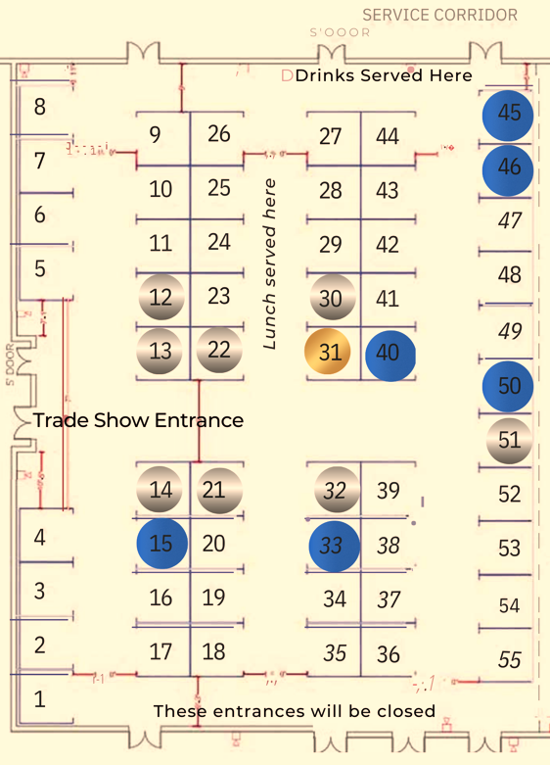

Exhibiting Sponsorships

- Title Sponsor: $6,000
- Promotional / Major Sponsor: $4,500
- Exhibitors: $1,000

Spaces and Prices

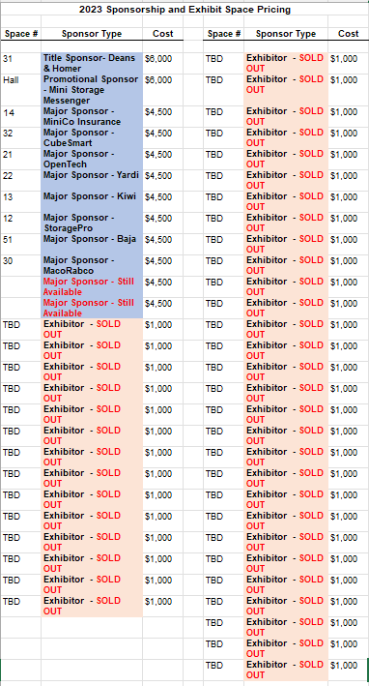

Exhibiting Sponsorship Benefits

Benefits for all Exhibiting Sponsors include:
- 1 person with access to all events on February 15 & 16, including meal and drink tickets
- Electricity upon request, at no additional cost
- Logo in sponsor video, shown throughout the 2-day conference
- Sponsor Material in Attendee Handouts – 1-page inserts supplied by sponsor in attendee tote bags
- On-stage announcement of door prize winners, after lunch on February 16

Title Sponsor – $6,000 – Deans & Homer
- First choice of exhibit space and 2 personnel
- 2-Minute Presentation by Sponsor at Opening Session both days
- Logo on name badges
- Your logo will be added to my signature line for the year
- Pre- and post-conference promotion, with logo on digital
brochures, postcards, name badges, conference slide show, event
posters, e-Bulletins, website ads, other promotional materials
- Vendor Spotlight Webinar to be played on tradeshow both days
- Recognition in all ads in trade publications such as Mini-Storage Messenger, ISS, SSA Magazine
- Recognition in AZSA’s print newsletter, Behind Closed Doors
- Additional drink tickets to give to attendees

Promotional Sponsor – Mini-Storage Messenger
- First choice of exhibit space after Title Sponsor
- All Major Sponsor benefits shown below

Major Sponsors – - $4,500 - Baja, CubeSmart, Kiwi II, MiniCo, OpenTech, StoragePro, Mako/Rabco and Yardi THANK YOU!
- Choice of best exhibit spaces after Title & Promo Sponsors and 2 personnel
- On-stage introductions both days of conference
- Pre- and post-conference promotion, with logo on digital brochures, postcards, name badges, conference slide show, event posters, e-Bulletins, website ads, other promotional material
- Vendor Spotlight Webinar to be played on tradeshow both days
- Recognition in AZSA’s print newsletter, Behind Closed Doors
- Recognition in all ads in trade publications such as Mini-Storage Messenger, ISS, SSA Magazine
- Additional drink tickets to give to attendees

Exhibitor - $1,000 – SOLD OUT

- All benefits listed on top of page
Charity Sponsor – Storage Gives – More details coming soon!

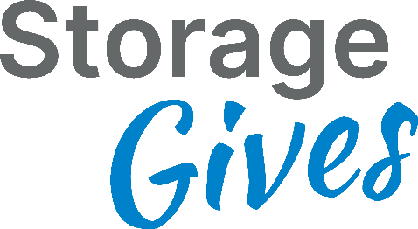

Additional Sponsorship Opportunity Details

Keynote - $6,000 (1)
- Opportunity to speak to all attendees during luncheon (10 minutes), February 15
- Recognition during Keynote Speaker presentation
- Recognition in digital and print promotional material pre-event (brochure, newsletter, eblasts,website) and during event (program, verbal recognition, sponsor video)
- Preferred exhibit space on trade show floor (exhibit fee not included in sponsorship)
- Sponsor Material in Attendee Handouts – 1 page inserts supplied by sponsor

Owners & Investor Summit Luncheon - $5,000 (3)
- First opportunity to speak to all attendees during luncheon (2 minutes), February 15
- Recognition throughout luncheon
- Recognition in digital and print promotional material pre-event (brochure, newsletter, eblasts, website) and during event (program, verbal recognition, sponsor video)
- Preferred exhibit space on trade show floor (exhibit fee not included in sponsorship)
- Sponsor Material in Attendee Handouts – 1 page inserts supplied by sponsor

Operational Program Luncheon - $5,000 (3)
- First opportunity to speak to all attendees during luncheon (2 minutes), February 16
- Recognition throughout luncheon
- Recognition in digital and print promotional material pre-event (brochure, newsletter, eblasts, website) and during event (program, verbal recognition, sponsor video)
- Preferred exhibit space on trade show floor (exhibit fee not included in sponsorship)
- Sponsor Material in Attendee Handouts – 1 page inserts supplied by sponsor

Owners & Investor Summit Breakfast - $2,500 (4)
- Opportunity to speak to all attendees during breakfast (2 minutes), February 15
- Recognition throughout breakfast
- Recognition in digital and print promotional material pre-event (brochure, newsletter, eblasts, website) and during event (program, verbal recognition, sponsor video)
- Preferred exhibit space on trade show floor (exhibit fee not included in sponsorship)
- Sponsor Material in Attendee Handouts – 1 page inserts supplied by sponsor

Operational Program Breakfast - $2,500 (4)
- Opportunity to speak to all attendees during breakfast (2 minutes), February 16
- Recognition throughout breakfast
- Recognition in digital and print promotional material pre-event (brochure, newsletter, eblasts, website) and during event (program, verbal recognition, sponsor video)
- Preferred exhibit space on trade show floor (exhibit fee not included in sponsorship)
- Sponsor Material in Attendee Handouts – 1 page inserts supplied by sponsor

AZSA Cocktail Hour Party - $5,000 (3)
- Opportunity to speak to all attendees during trade show reception (2 minutes), February 15
- Recognition throughout reception
- Recognition in digital and print promotional material pre-event (brochure, newsletter, eblasts, website) and during event (program, verbal recognition, sponsor video)
- Prime exhibit placement next to beverages (exhibit fee not included in sponsorship)
- Sponsor Material in Attendee Handouts – 1 page inserts supplied by sponsor
- Sponsor of refreshments on the trade show floor
- Signage on refreshment table sponsored
- Recognition in digital and print promotional material pre-event (brochure, newsletter, eblasts, website) and during event (program, verbal recognition, sponsor video)
- Premium exhibit placement next to refreshments (exhibit fee included)
- Sponsor Material in Attendee Handouts – 1 page inserts supplied by sponsor

Snack Sponsorship - $2,000 (2)
- Sponsor of refreshments on the trade show floor
- Signage on refreshment table sponsored
- Recognition in digital and print promotional material pre-event (brochure, newsletter, eblasts, website) and during event (program, verbal recognition, sponsor video)
- Premium exhibit placement next to refreshments (exhibit fee included)
- Sponsor Material in Attendee Handouts – 1 page inserts supplied by sponsor

Session Sponsors - $1,500 (6)
- On-stage introduction before session sponsored
- Recognition throughout session sponsored
- Recognition in digital and print promotional material pre-event (brochure, newsletter, eblasts, website) and during event (program, verbal recognition, sponsor video)
- Preferred exhibit space on trade show floor (exhibit fee not included in sponsorship)
- Sponsor Material in Attendee Handouts – 1 page inserts supplied by sponsor

Tote bags - $2,000 – NSA Brands – SOLD OUT
Ceremonial Opening Tribal Blessing - $1,500 – MiniCo Publishing – SOLD OUT

Lanyards - $1,500 – William Warren Group – SOLD OUT
Beverage Sponsorship - $1,000 – SOLD OUT

To register for additional sponsorship

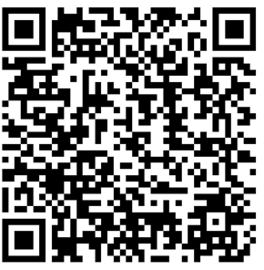

Specifications

Space:

  - Set up and break down times are strict. All exhibits must be set up by 8:30 am on Wednesday, February 15; breakdown may not start until 4:15 pm on Thursday, February 16. Please plan accordingly.
  - All space includes electricity if you request it.
  - Exhibiting Sponsors may not sublet, assign, or share any part of space allocated to them without the written consent of AZSA. Exhibits, signs, and displays are also prohibited in any of the public areas or elsewhere on the premises of the hotel facilities. Any company not assigned space is prohibited from hosting hospitality suites or displaying or distributing materials at the hotel.

Exhibit Details:

Exhibits:
    - All exhibits are 10’x 10’ pipe & drape booths with 6’ tables and cloths and a chair. Each booth will consist of 8’ high back wall, 3’ high side rails, one wastebasket and one 7” x 44” ID sign.
    - For other booth and event enhancements like charging stations, furniture and other products please contact:

Matt Palmer

matt.palmer@convention-si.com

Convention Solutions & Innovation (CSI)
3701 West Cambridge Avenue, Phoenix, AZ 85009
| D: 602.730.8103 | M: 602.425.7769 | E: matt.palmer@convention-si.com

    - Logistics Service Kit will be available at the beginning of January

Floor plan, traffic flow, and other issues:

  - Floor plan is approximate
  - Entrance/exit – as marked
  - Meals:
- Buffet – Ticketed meals will be served buffet style in the exhibit hall
- Meal seating – will be in the attendee seating areas & other designated areas
  - Beverage service - will be throughout both days

